

Contact:
Emma Kramer
Jasper Paul PR & Marketing
618-541-2103
emma@jasperpaulpr.com
SWADE UNVEILS FLAGSHIP DISPENSARY WITH ST. LOUIS’ FIRST 24/7 DRIVE-THROUGH IN OVERLAND, MARKING NEXT PHASE OF BRAND EVOLUTION IN MISSOURI
The new location introduces an expanded retail space, delivery hub, and St. Louis’ first 24/7 cannabis pickup option
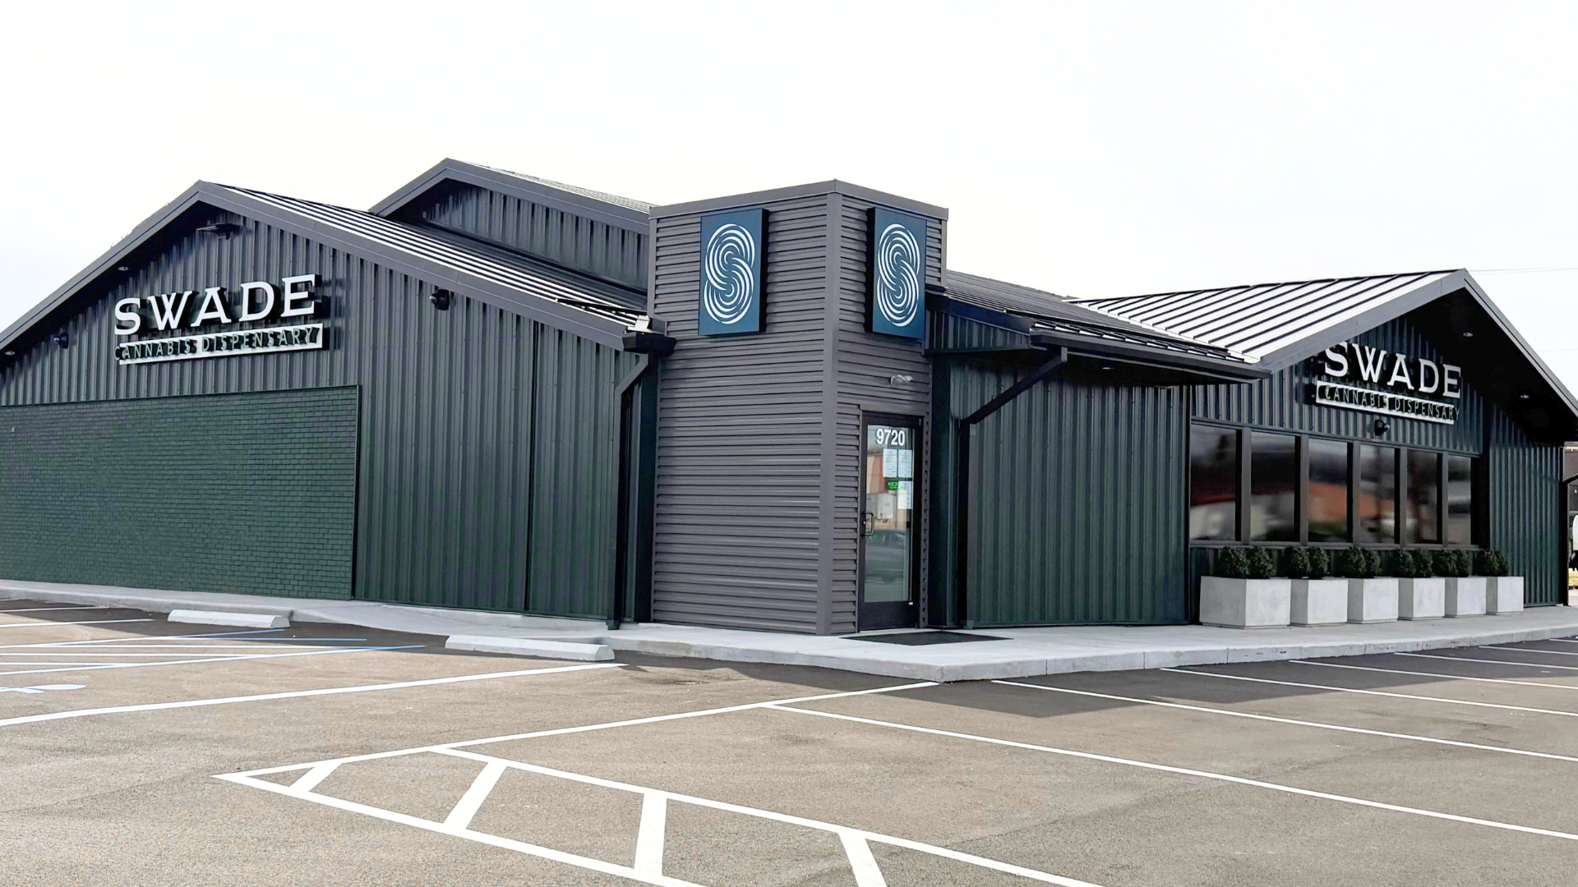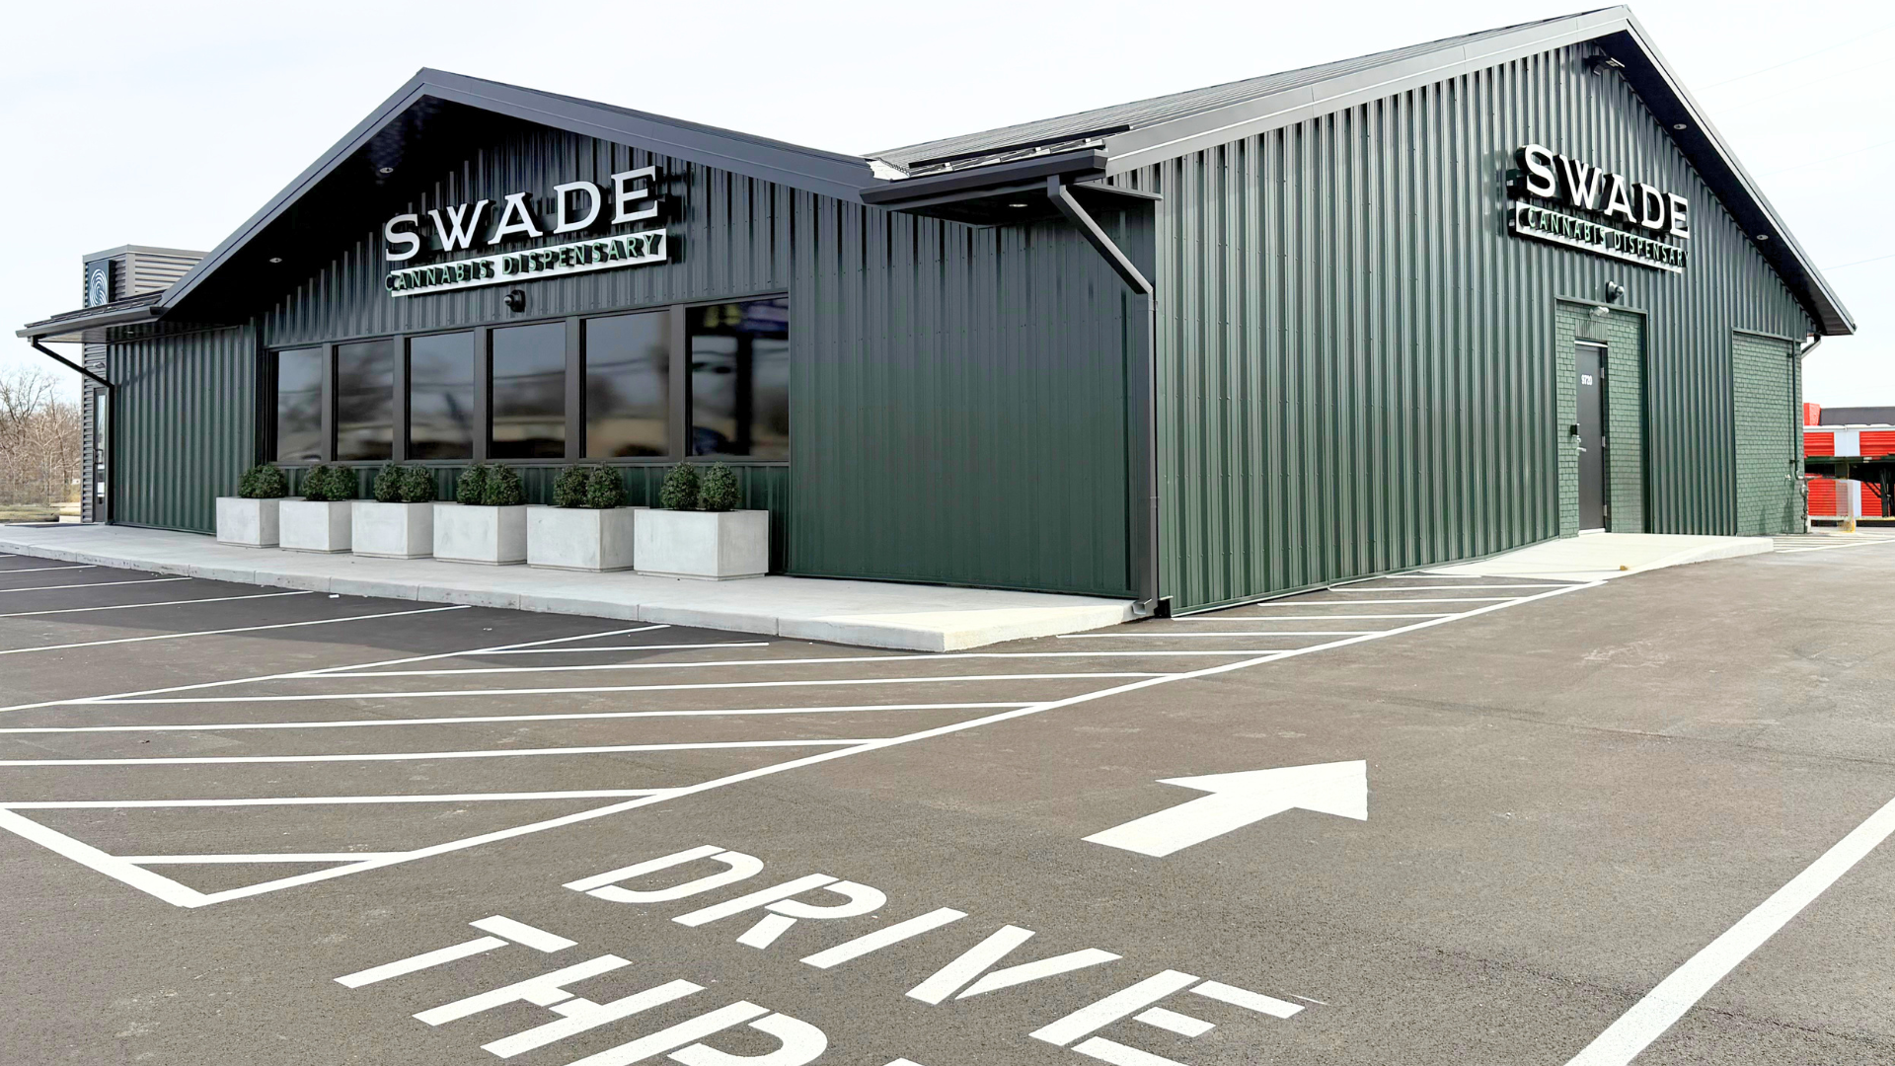
Swade Cannabis’ Overland Dispensary (Dropbox Link)
ST. LOUIS (March 26, 2026) — SWADE Cannabis, a premium dispensary network with 11 locations across Missouri and exclusive Sinse brand of flower-based products, is entering its next phase of growth in Missouri with the upcoming opening of a new flagship dispensary in Overland (9720 Page Avenue, St. Louis, MO 63132), reflecting the company’s continued evolution toward greater convenience, accessibility, and innovation in the state’s cannabis market. Opening on Saturday, March 28, the new location will expand SWADE’s statewide footprint to 12 dispensaries across Missouri while introducing new operational features that represent the future of the brand’s retail and delivery experience. The dispensary location, boasting 3,759 square feet of space for retail and delivery operations, will debut a 24/7 preorder drive-thru pickup window for both medical and adult-use customers, the first of its kind in St. Louis and only the second in the state of Missouri. Customers will be able to place orders online and pick them up anytime through the dedicated pickup window.
The Overland dispensary will serve as a central delivery hub for one of the largest service zones in the St. Louis region, including high-traffic communities such as Maryland Heights, Ladue, Clayton, and Olivette. SWADE offers the most efficient cannabis delivery service in Missouri, guaranteeing same-day, discreet delivery. The Overland dispensary will feature an expanded retail space along with infrastructure to support SWADE’s growing delivery operations. Customers will also gain access to SWADE’s newly announced Passport membership program and enhanced loyalty initiatives, offering exclusive perks, rewards, and savings on deli-style strains.
“This location represents an important step forward in the evolution of the SWADE brand,” said Kevin Riggs, CEO of BeLeaf Medical, parent company of SWADE Dispensaries. “As Missouri’s cannabis market continues to mature, our focus is on creating a more modern, convenient experience for our customers.
Beyond expanding consumer access, the new dispensary will also bring more than 40 new jobs to the Overland region, including budtenders, management staff, security personnel, and delivery drivers. The company selected Overland for its strategic location within St. Louis County, offering convenient access to multiple neighborhoods through major thoroughfares and enabling efficient delivery coverage across key areas of the metro region.
Overland dispensary operations are scheduled to begin Saturday, March 28, and a larger Grand Opening Celebration is planned for May. Details to be announced through SWADE’s social media channels. For more details, visit www.swadecannabis.com or their social media here.
FOR MORE INFORMATION OR INTERVIEW REQUESTS, PLEASE CONTACT EMMA KRAMER AT (618) 541-2103
About SWADE Cannabis: SWADE Cannabis is Missouri’s premier destination for curated cannabis, delivering an elevated experience since opening in 2021 as one of the state’s first dispensaries. Owned by BeLeaf Medical, SWADE operates as part of a vertically integrated company, with its exclusive Sinse brand offering premium flower-based products grown in controlled environments. With six locations in the St. Louis metro area and now five additional dispensaries in Kansas City, SWADE designs each store to reflect its community’s unique character, fostering personalized, educational experiences. Through events and partnerships, SWADE shapes Missouri’s vibrant cannabis culture. For more information, follow Swade on Instagram or visit www.swadecannabis.com.

###

