9666 Olive BLVD STE 685 / Olivette, Mo 63132
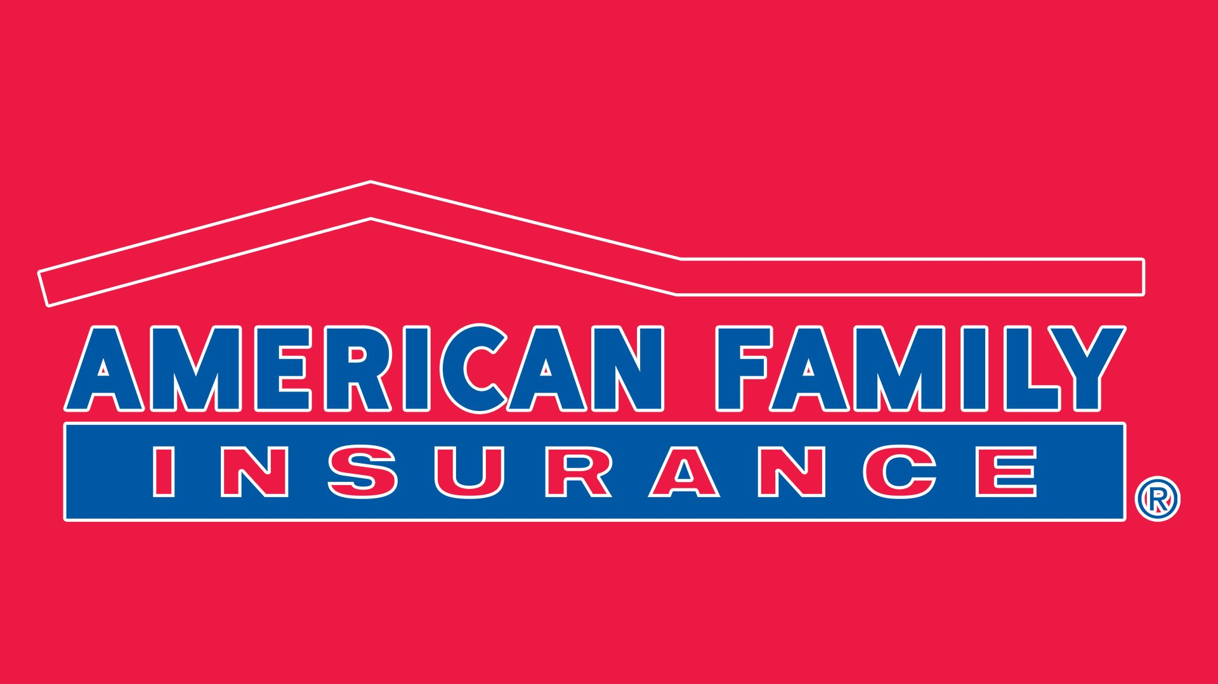  RIBBOn CUTTING |  | 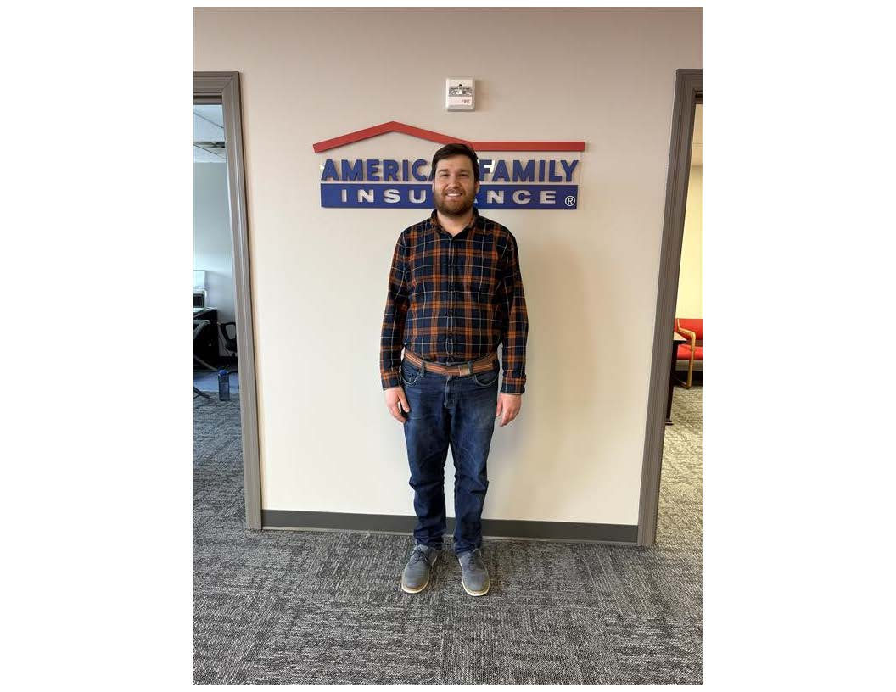
Thursday, April 24th
We’re thrilled to invite you to the ribbon-cutting ceremony of Robert J Boyer and Associates LLC Insurance Agency. Celebrate with us as we open our doors to serve the community with trusted and reliable insurance services.
- Ribbon Cutting at 11:30 AM
- Complimentary Refreshments and Light Snacks
- Meet the Team and Learn More About Our Services
- Door Prizes and Special Offers Available
- Networking Opportunities
Whether you're looking for personal, business, or specialty insurance, we are here to help you protect what matters most!

Agent Robert J Boyer and Team  314-432-3221  Rboyer@amfam.com |  | 
BoyerInsuresSTL.com

