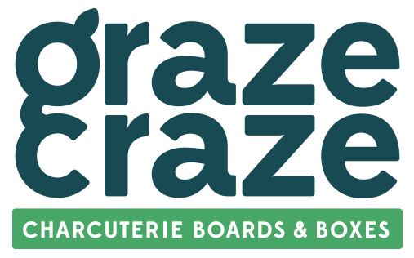

Celebrate Everything with New Graze Craze Charcuterie Shop in Creve Coeur
Local couple bring delicious graze-style dining to the community, taking special events and everyday moments to the next level

CREVE COEUR, Mo. (March 24, 2025) – Graze Craze® is bringing its elevated take on graze-style dining to Creve Coeur, where the innovative brand is opening a new store in the Plaza Shops at 715 N. New Ballas Road. The 1,050-square-foot shop is owned by local entrepreneur, Zulfi Bhatti, who is eager to serve Creve Coeur and celebrate special occasions with beautifully crafted charcuterie boards and boxes.
At Graze Craze, Bhatti leads a team of expert Grazologists™ who artfully design a variety of grazing options created with the brand’s motto Celebrate Everything in mind. The menu features an array of high-quality ingredients, like premium meats and cheeses, fresh fruits, crisp vegetables and more, accompanied by house-made sauces, dips and jams. Each grazing spread features a complementary blend of flavors, colors and textures that produce an eye-catching work of edible art.
“We’re proud to bring something fresh and different to the local food scene,” said Bhatti. “It's exciting that we get to share a unique food experience that provides the perfect solution for people looking for deliciously convenient ways to feed a crowd.”
Each Graze Craze charcuterie board explores exciting flavor profiles and combinations using the finest gourmet ingredients. Popular menu selections include
- The Gone Grazey – A blend of cured meats, premium cheeses, crackers, fresh produce, nuts and more.
- The Vegegrazian – A vibrant medley of fruits and vegetables.
- The Brunch Board – A selection of breakfast meats, fresh fruits, eggs, pastries and more to complement morning meetings and events.
- The Sweet & Grazey – One of Bhatti’s favorites; an abundance of desserts, like chocolates and baked goods, paired with sweet dips.
Bhatti gained years of customer service experience operating local delis throughout the Town-and-Country-area, inspiring his passion for community and connection. “I’ve always been drawn to the food industry and Graze Craze stands out because it’s not just about selling food,” said Bhatti. “It’s about creating an experience, and the process of curating beautifully delicious offerings for our clients' special moments is something I truly enjoy.”
Graze Craze Creve Coeur is open Monday-Friday 10 a.m.-5 p.m., Saturday 10 a.m.-2 p.m. and Sunday by appointment only. For more information, including special orders, catering and events, call 314-744-5652 or visit WEBSITE and follow along on Facebook at @GrazeCrazeCreveCoeurMO and Instagram at @USERNAME.

About Graze Craze
Graze Craze® is the leading franchise within the grazing style food category, offering an alternative experience to traditional dining options and catering for every occasion. At Graze Craze, in-store Grazologists™ curate hand-crafted, impeccably designed, sweet and savory charcuterie boards and picnic boxes made with the highest quality ingredients and arranged with perfection. Graze Craze is an affiliated brand of United Franchise Group™, the global leader for entrepreneurs, within the United Franchise Group’s food division, Big Flavor Brands™. For more information about Graze Craze locations, menu, and commercial accounts visit www.grazecraze.com. For information on franchising opportunities, visit www.grazecrazefranchise.com.

About Big Flavor Brands
Big Flavor Brands™ specializes in franchises dedicated to creative eating, offering a zesty menu of fast-growing, award-winning food brands with a proven track record of success. From fast-casual restaurants with authentic third-generation recipes like The Great Greek Mediterranean Grill®, to specialty concepts like the grazing innovator and charcuterie board caterer Graze Craze®, and the super-fast, fresh Italian experience of Cannoli Kitchen Pizza®, Big Flavor Brands dominate their niches with quality, value, and tasty fare for every occasion. Big Flavor Brands represents the food division of United Franchise Group™ which is comprised of innovative concepts pushing the boundaries with an unwavering commitment to quality, variety, and the pursuit of joyful eating.
###

